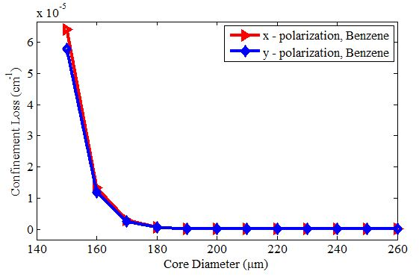
Benzene

Fig. 1: Confinement loss vs Core Diameter
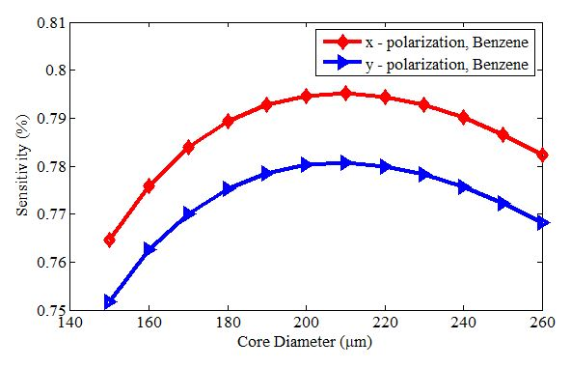

Fig. 2: Sensitivity vs Core Diameter

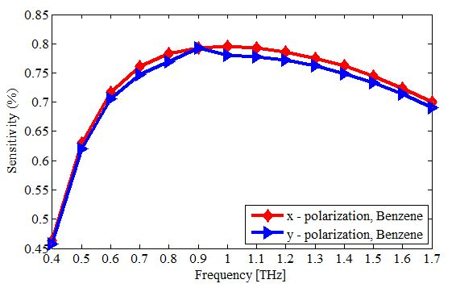
Fig. 3: Sensitivity vs Frequency
Ethanol
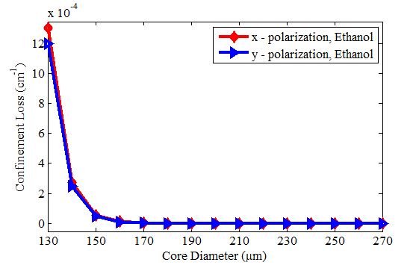
Fig. 4: Confinement loss vs Core Diameter
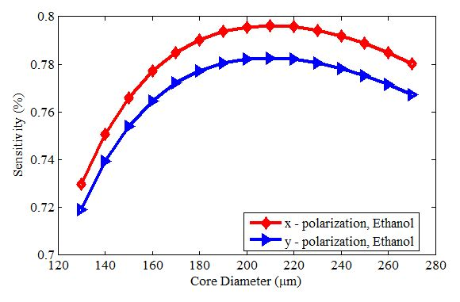
Fig. 5: Sensitivity vs Core Diameter
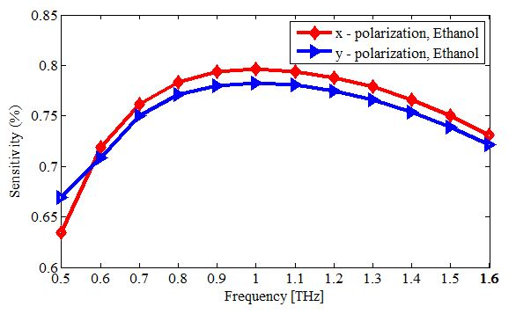
Fig. 6: Sensitivity vs Frequency

Comparison of Benzene vs Ethanol

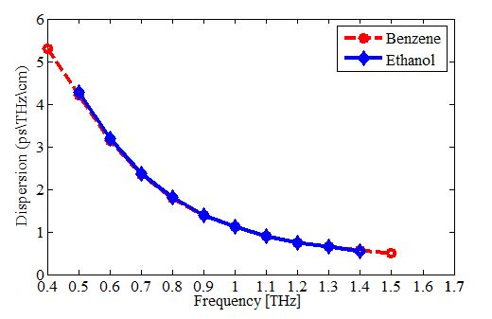
Fig. 7: Dispersion vs Frequency
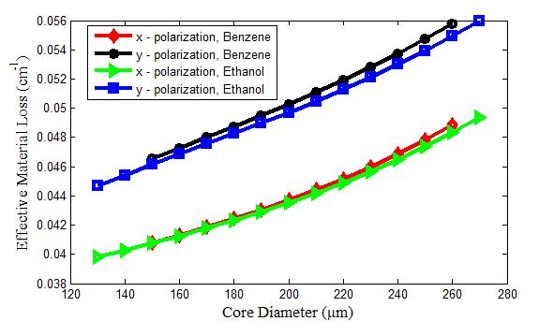
Fig. 8: EML vs Core Diameter
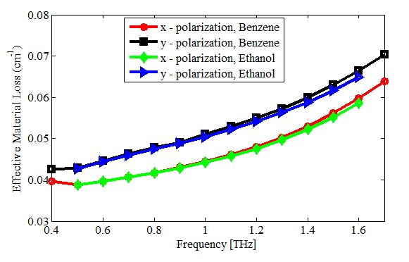
Fig. 9: EML vs Frequency

