Abstract— We experimentally demonstrate a passively Q-switched erbium-doped fiber laser (EDFL) operation by using a saturable absorber (SA) based on tungsten disulfide (WS₂). By depositing WS₂ thin film layer at the end of optical fiber ferrule, we fabricated a SA device. The SA is incorporated into an Erbium-doped fiber laser (EDFL) cavity to generate a Q-switching pulses train operating at 1559.8 nm. As a result, stable passively Q-switched EDFL pulses with maximum output pulse energy of 123.2 nJ, repetition rate of 104.1 kHz, and pulse width of 9.61 μs are achieved when the input pump power is 142.1 mW at the wavelength of 980 nm.
Q-switched fiber laser with tungsten disulfide saturable absorber prepared by drop casting method
N. N. Razak¹, M. Yasin^{2*}, Z. Zakaria¹, A. A. Latif¹ and S.W.Harun³
¹Faculty of Electronic and Computer Engineering, Universiti Teknikal Malaysia Melaka, 76100 Melaka, Malaysia
²Department of Physics, Faculty of Science and Technology, Airlangga University, Surabaya, Indonesia
³Photonics Engineering Laboratory, Department of Electrical Engineering, University of Malaya, 50603 Kuala Lumpur, Malaysia
*E-mail: yasin@fst.unair.ac.id

Due to the merits of high slope efficiency, good beam quality and stable operation, Q-switched fiber lasers always have extensive applications in the fields of spectroscopy, optical communications, material processing, biomedicine and so on [1, 2]. To date, besides the traditional semiconductor saturable absorber mirrors (SESAMs) [3], there are several new materials, such as carbon nanotubes (CNTs) [4], Graphene [5-6], topological isolators (TIs) [7-8], transition metal dichalcogenides (TMDs) [9] and black phosphorus [10], which have been used as the SAs. Compared with SESAMs, these emerging materials possess the excellent virtues of broader operation wavelength band, more excellent nonlinear optical response, and easier fabrication. Among them, a group of semiconducting TMDs, like tungsten disulfide (WS₂) and molybdenum disulfide (MoS₂), have stood out for their typical graphene-like two-dimensional (2D) layered structure, unique thickness-dependent bandgap and stronger light–matter interaction than graphene [11].
According to these outstanding optical characteristics, different forms of SAs based on WS₂ or MoS₂ have been fabricated and applied to mode-locked and Q-switched lasers [11-12]. Most of the reported Q-switched lasers have low output power. For instance, Wu et al. demonstrated a Q-switched EDFL with the maximum pulse energy of 46.3 nJ using WS₂ nanosheets, which were prepared using liquid-phase exfoliation method and embedded in polyvinyl alcohol (PVA) thin film [13]. In this letter, we demonstrate a Q-switched EDFL using WS₂ based SA, which was prepared using a drop casting method. Compared with the previous work, the proposed laser produced a higher maximum pulse energy of 123 nJ. The SA is developed by repeatedly dropping the WS₂ onto fiber ferrule and the dried SA device is incorporated in the ring laser cavity. This technique offers simplicity in fabrication compared to composite film, besides allows control over insertion loss.
In the experiment, we used WS₂ pristine flakes solution, which was obtained by the liquid exfoliation method. The WS₂ flakes with purity of more than 99% was dispersed by using a mixture of ethanol and water as solvent. Then the dispersed solution was treated for 120 min by a high-power ultrasonic cleaner. After sonication, the dispersion was allowed to settle for several hours. To remove large agglomeration, the dispersion was centrifuged at 3000 rpm for 30 min, and the upper supernatant was then collected. The concentrations of WS₂ nanosheets in the dispersed solution was about 26 mg/l. The WS₂ solution was repeatedly dropped and dried onto fiber ferrule until it forms WS₂ thin film layer that was strong enough to act as an SA for the laser cavity. This method, although simple and easy, is a viable alternative to the methods previously used. The fabrication process is illustrated in Fig. 1.
The deposited WS₂ thin film is characterized by Raman spectroscopy using Argon laser at 514 nm. The Raman spectrum obtained is depicted in Fig. 2(a). It indicates the characteristic bands at 350.8 and 420.7 cm⁻¹, which are assigned to the in-plane (E_{2g}) and out-of-plane (A_{1g}) vibrational modes of WS₂. Fig. 2(b) shows the scanning electron microscopy (SEM) image of WS₂ thin film, which has a lateral size in the range of 50 to 150 nm.
The fabricated SA device was integrated into an EDFL cavity for Q-switching generation as shown in Fig. 3. The cavity uses a 3-m-long erbium-doped fiber (EDF), which was pumped by a 980-nm laser diode (LD) via a 980/1550 nm wavelength division multiplexer (WDM). The EDF used has a numerical aperture (NA) of 0.16 and erbium ion absorption of 23 dB/m at 980 nm with core and cladding diameters of 4 µm and 125 µm, respectively. To ensure unidirectional propagation of the oscillating laser in the ring laser cavity, a polarization-independent isolator was used. The laser signal was coupled out using 80:20 output coupler while keeping 80% of the light to oscillate in the ring cavity, for both spectral and temporal diagnostics. The output laser was tap from a 20 % port of the coupler. The spectral characteristic was measured using an optical spectrum analyzer (OSA) with a spectral resolution of 0.02 nm while the temporal characteristics were measured using a 500 MHz oscilloscope and a 7.8 GHz radio-frequency (RF) spectrum analyser via a 1.2 GHz photodetector.

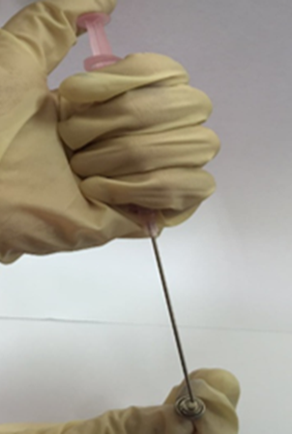
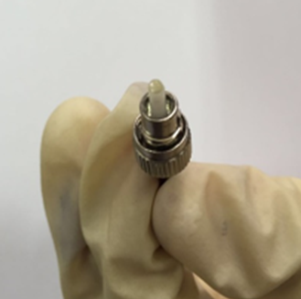
(a)
(b)

Fig. 1. Preparation of SA from the WS₂ flakes solution (a) dripping the SA solution onto a fiber ferrule using a pipette (b) drying process at room temperature
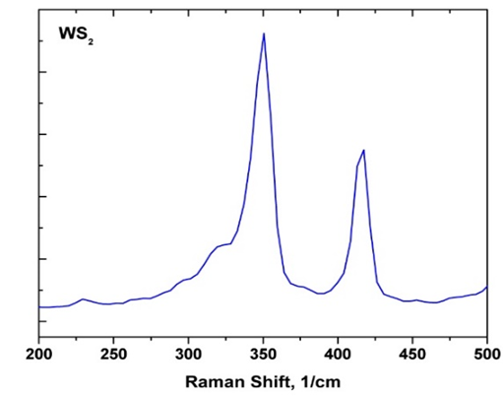
(a)
(b)
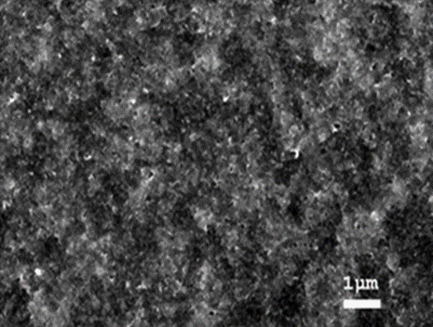

Fig. 2. Characteristics of WS₂ thin film (a) Raman spectrum (b) SEM image

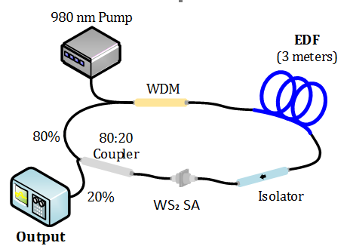

Fig. 3. Configuration of the WS₂ based Q-switched EDFL
In this experiment, the pump power was slowly raised until we obtain a stable Q-switched pulse train when the pump power exceeds lasing threshold. Stable, robust and self-starting Q-switching operation is obtained at pump power threshold of 60.6 mW. CW lasing was observed below the threshold pump power. The Q-switching operation was maintained up to pump power of 142.1 mW. Fig. 4(a) presents the measured emission spectrum of the Q-switched EDFL, which indicates the laser operation at 1559.8 nm. Fig. 4(b) shows the typical oscilloscope trace of the Q-switched pulse train at the pump power of 142.1 mW. It shows the peak-to-peak duration of 9.6 µs, which is equal to the repetition rate of 104.1 kHz. It is also observed that the Q-switched pulse output is stable and no amplitude modulations in the pulse train can be observed, which indicates that there is no self-mode locking effect during the Q-switching operation. Moreover, the peak amplitude of the pulse is observed to be constant throughout the projection and this shows that the Q-switched pulse is stable at laboratory environment.
To verify the effects of the WS₂-based SA on Q-switching, two optical fiber connectors connected by a flange are inserted in the EDFL cavity. But there is no WS₂ flakes film deposited on the end of the optical fiber connector. And the corresponding SMFs' length is not changed. It is observed that, only continuous wave laser operation is obtained and no pulsed operation was observed when the pump power is varied within a wide range. This confirmed that the above Q-switched EDFL has been induced by the WS₂-based SA.
To investigate the stability of Q-switching operation, we measure the signal to noise ratio of RF signal transformed by photodiode and analyse the spectrum with the help of RF spectrum analyser. Fig. 4(c) shows the RF spectrum at pump power of 142.1 mW. As illustrated in the figure, the fundamental repetition rate of the laser is obtained at 104.1 kHz with a signal-to-noise ratio of more than 65 dB. This indicates that the stability of the produced pulses are excellent. Agree to Fourier transform, the peak of fundamental repetition rate gradually decrease until the 6th harmonic. Throughout the experiment, we can confirm that no mode-beating frequency presence.
During the process of increasing pump powers, the repetition rate of output stable pulses monotonically increases from 70.0 kHz to 104.1 kHz while the pulse width reduces from 14.28 μs to 9.61 μs, as shown in Fig. 5 (a). It can be found that the repetition rate becomes larger and the pulse width becomes smaller with the increasing pump power. This also presents a typical feature of passively Q-switched lasers. The pump rate for the upper laser level increases with increasing the pump power and causes the reduction of the pulse width and the increase of the repetition rate. The demonstrated laser shows no obvious degradation at the laboratory condition for 2 hours. In our experiment, the laser becomes CW operation when the pump power goes beyond 142.1 mW. If the pump power is reduced to 142.1 mW again, the Q-switching reappeared. This is because WS₂ exhibits a saturable absorption at moderate laser intensities, while optical limiting induced by excited states absorption would occur at higher intensities.

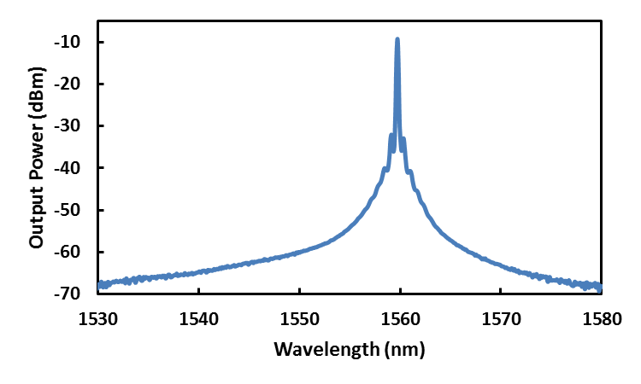
(a)
(b)
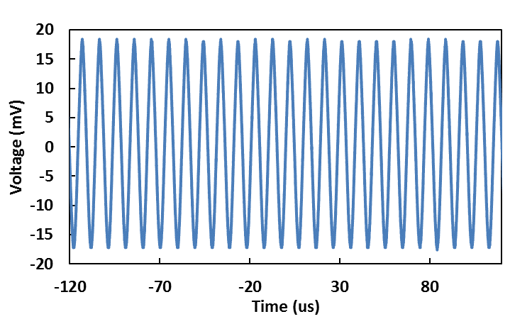
(c)
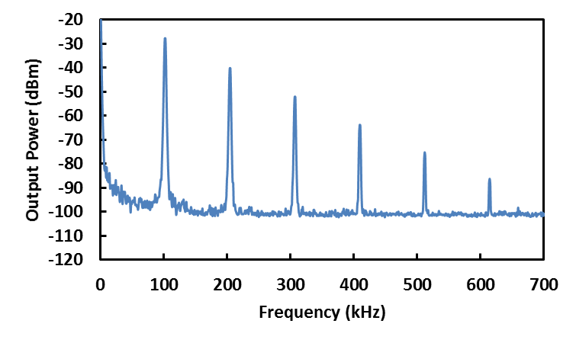
Fig. 4. Spectral and temporal characteristics at pump power of 142.1 mW (a) Output spectrum (b) typical pulse train (c) RF spectrum

Pulse energy is found to change with the increment of the pump power and the output power monotonically. The corresponding output power increased from 5.98 mW to 12.82 mW and the single pulse energy varied from 77 nJ to 123 nJ, as shown in Fig. 5(b). The laser efficiency is about 9.15%. The slope efficiency is reasonably high due to the relatively low cavity loss. The output pulse with energy of 123 nJ was achieved at the maximum pump power of 142.1 mW. This Q-switching performance could be further improved by optimizing the cavity design and the SA parameters such as modulation depth and insertion loss.

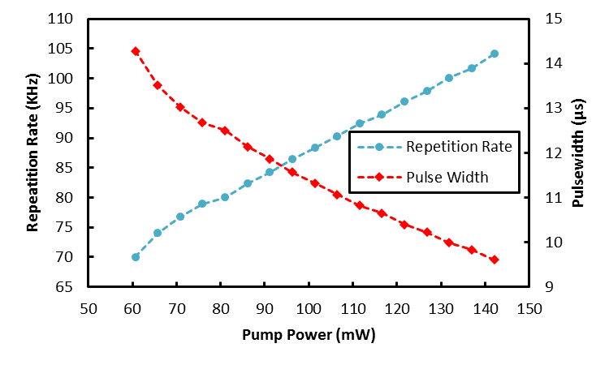
(a)

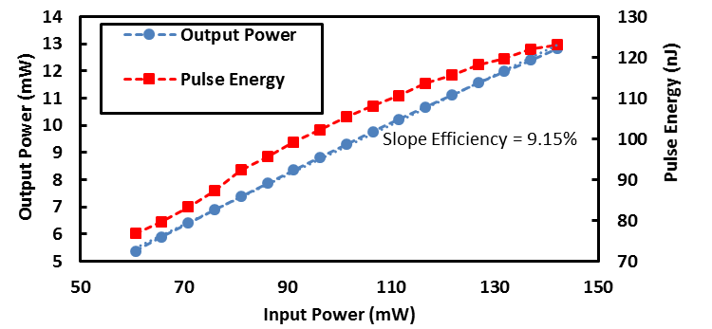
(b)

Fig. 5. Q-switching performances (a) The pulse repetition rate and pulse width against pump power (b) the average output power and the corresponding single-pulse energy against pump power

In conclusion, the proposed Q-switched EDFL operating at 1559.8 nm using a WS₂ material as a SA was successfully demonstrated. The SA film was fabricated by a simple drop and casting technique. It was obtained by repeatedly dropping the WS₂ solution onto fiber ferrule and the dried SA device is incorporated in the ring laser cavity. A stable Q-switched pulse train was obtained as the pump power reached the threshold value of 60.6 mW and it continued to operate stably until 142.1 mW. The corresponding pulse repetition rate was tunable from 70.0 to 104.1 kHz. The lowest pulse width was 9.16 µs and the maximum pulse energy was 123 nJ. Our experimental results suggest that WS₂ is a promising material for pulsed laser applications.

References

[1] U. Sharma, C. Kim, J. U. Kang, and N. M. Fried, “Highly stable tunable dual-wavelength Q-switched fiber laser for DIAL applications,” in Laser Applications to Chemical and Environmental Analysis (Optical Society of America, 2004), p. B3.
[2] M. Skorczakowski, J. Swiderski, W. Pichola, P. Nyga, A. Zajac, M. Maciejewska, L. Galecki, J. Kasprzak, S. Gross, A. Heinrich, and T. Bragagna, “Mid-infrared Q-switched Er:YAG laser for medical applications,” Laser Phys. Lett. 7(7), 498–504 (2010).
[3] C. Gao, W. Zhao, Y. Wang, S. Zhu, G. Chen, and Y. Wang, “Passive Q-switched fiber laser with SESAM in ytterbium-doped double-clad fiber,” in 27th International congress on High-Speed Photography and Photonics (International Society for Optics and Photonics, 2007), p. 62794G.
[4] M. Ahmed, N. Ali, Z. Salleh, A. Rahman, S. Harun, M. Manaf, et al., "Q-switched erbium doped fiber laser based on single and multiple walled carbon nanotubes embedded in polyethylene oxide film as saturable absorber," Optics & Laser Technology, vol. 65, pp. 25-28, 2015.
[5] M. A. Ismail, F. Ahmad, S. W. Harun, H. Arof and H. Ahmad, “A Q-switched erbium-doped fiber laser with a graphene saturable absorber,” Laser Phys. Lett. 10, 025102 (2013)
[6] G. Sobon, J. Sotor, J. Jagiello, R. Kozinski, K. Librant, M. Zdrojek, L. Lipinska, and K. M. Abramski, “Linearly polarized, Q-switched Er-doped fiber laser based on reduced graphene oxide saturable absorber,” Appl. Phys. Lett. 101, 241106 (2012)
[7] N. H. M. Apandi, F. Ahmad, S. N. F. Zuikafly, M. H. Ibrahim, S. W. Harun, “Bismuth (III) Telluride (Bi2Te3) topological insulator embed in PVA as passive Q-switcher at 2 micron region,” Photon. Lett. of Poland, vol. 8, No. 4, pp. 101-103, (2016).
[8] J. Bogusławski, G. Soboń, K. Tarnowski, R. Zybała, K. Mars, A. Mikuła, K. M. Abramski and J. Sotor, "All-polarization-maintaining-fiber laser Q-switched by evanescent field interaction with Sb2Te3 saturable absorber", Optical Engineering 55, 081316 (2016).
[9] Z. Luo, Y. Huang, M. Zhong, Y. Li, J. Wu, B. Xu, H. Xu, Z. Cai, J. Peng, and J. Weng, “1-, 1.5-, and 2-μm fiber lasers Q-switched by a broadband few-layer MoS2 saturable absorber,” J. Lightwave Technol. 32(24), 4679–4686 (2014).
[10] N. N. Razak, A. A. Latiff, Z. Zakaria and S. W. Harun, “Q-switched Erbium-doped Fiber Laser with a Black Phosphorus Saturable Absorber,” Photon. Lett. of Poland, Vol. 9, No. 2, pp. 72-74 (2017)
[11] Y. Huang, Z. Luo, Y. Li, M. Zhong, B. Xu, K. Che, H. Xu, Z. Cai, J. Peng, and J. Weng, “Widely-tunable, passively Q-switched erbium-doped fiber laser with few-layer MoS2 saturable absorber,” Opt. Express 22(21), 25258–25266 (2014).
[12]D. Mao, Y. Wang, C. Ma, L. Han, B. Jiang, X. Gan, S. Hua, W. Zhang, T. Mei, and J. Zhao, “WS2 mode-locked ultrafast fiber laser,” Sci Rep 5, 7965 (2015).
[13]K. Wu, X. Zhang, J. Wang, X. Li, and J. Chen, “WS2 as a saturable absorber for ultrafast photonic applications of mode-locked and Q-switched lasers,” Optics Express 23, pp. 11453-11461, (2015).

