Abstract—This paper presents an efficient search method for equivalent thin film filter realizations under boundary conditions to a given design. To calculate realizations the algorithm presented in [1] is used and the boundary conditions are given in form of refractive index intervals. Since the number of possible solutions increases exponentially with the number of film layers, only a small part of them can be checked for boundary conditions in a reasonable time. The method presented here uses the results of a Monte Carlo simulation and Yen's algorithm. The time consuming simulation is conducted only once for given boundary conditions. Since the boundary conditions depend on the fabrication process this method saves a significant amount of time during filter design.
A design method for high order optical thin film filters under boundary conditions
B. Diehm¹, C. Gulde, and N. Frühauf¹
¹Chair of Display Technology and Research Center SCoPE, Universiät Stuttgart, Allmandring 3b, 70569 Stuttgart, lfb@lfb.uni-stuttgart.de, http://www.lfb.uni-stuttgart.de

I Introduction and problem description

In [1] an exact synthesis algorithm for dielectric thin film filters with uniform optical phase thickness is presented which is based on a synthesis method for lossless electric lines [3] and reactance networks [4]. This algorithm has the benefit of providing all possible solutions in terms of thin film filter stacks to a given transmission or reflection characteristic under the restrictions stated above. In [1] it is only assured that the refractive indices of all solutions have strictly positive values. Unfortunately this is insufficient for a technological realization since refractive indices of practical materials only exist as discrete values. One way to alleviate this restriction is to use a mixture of materials with different refractive indices for layer fabrication [5-7]. Another way is to replace a given refractive index layer by a symmetric system of three layers by application of the Herpin equivalent index theorem [8-11]. Both ways are especially suited to create arbitrary refractive index values in a certain interval which is bounded by two refractive indices n_{L} and n_{H}. From a technological point of view this subset of realizable solutions is of substantial interest. Instead of refractive indices n optical admittances η known from [12] which are given by $\text{η=n}⋅\sqrt{ε_{0}⋅μ_{0}^{−1}}$will be used in the following. The boundary condition in this paper is therefore given by equation (1).
$0{\text{<η}}_{L}≤η_{j}≤η_{H}\text{,j=}\text{1,}…\text{,N}$ | (1)
The synthesis algorithm presented in [1] states necessary and sufficient conditions for the feasibility of the filter's transmission T as a function of the uniform phase thickness δ which is given in equation (2).
$\text{δ=}\text{2π}⋅n⋅d⋅λ^{−1}$ | (2)
As mentioned above only strictly positive admittance values are guaranteed. With respect to equation (1) the following questions arise. Are there any thin film stacks among the equivalent solutions which fulfill equation (1)? Is there an efficient search method for these solutions especially if the filter order respective the number of thin film layers N is high? Regarding the first question only precise necessary conditions can be stated for low order filters by using various algebraic and numeric methods at the moment. This subject will be treated in a subsequent paper. In this paper the second problem is tackled. The paper is organized as follows: Section II gives a short summary of [1] with emphasis on how to determine equivalent solutions. In section III the used Monte Carlo simulation is presented whereas section IV describes the used search process which employs Yen's algorithm [2]. A short example with simulation results is presented in section V.

II The exact thin film filter synthesis algorithm

First consider the derivation of the characteristic matrix M and the transmission T for a general dielectric thin film filter stack with N layers presented in [12]. The stack is embedded in an ambient medium with the admittance η₀ on one side and a substrate medium with η_{N+1} on the other side. By demanding uniform optical phase thickness for all layers the frequency variable δ as given in equation (2) can be used. Now a well known frequency transformation s = σ + iΩ = tan(iδ) presented in [3] and [13] with s as new complex frequency variable and Ω = Im{s} is introduced. By mapping the interval δ=[-π/2;π/2] onto the whole imaginary axis in the s-plane this frequency trans-formation links the optical synthesis problem considered here to well known concepts for the synthesis of lossless transmission lines with uniform time delay and reactance filters [13],[4]. By using this approach we get M(s), τ(δ) and T(δ) as given in equation (3), (4) and (5).
$M\left(s\right)=\frac{1}{\sqrt{{1−s^{2}}^{N}}}⋅\prod_{r=1}^{N}{\left(\begin{matrix}1 & s⋅η_{r}^{−1} \\ s⋅η_{r} & 1\end{matrix}\right)}=\left(M_{\text{ij}}\right)$ | (3)
$τ\left(δ\right)={\left[\frac{2\sqrt{{1−s^{2}}^{N}}}{M_{\text{11}}{\text{+η}}_{\text{N+}1}M_{\text{12}}+\frac{1}{η_{0}}M_{\text{21}}+\frac{η_{\text{N+}1}}{η_{0}}M_{\text{22}}}\right]}_{\text{s=}\text{tan}\left(iδ\right)}$ | (4)
$T\left(δ\right)=\frac{η_{\text{N+}1}}{η_{0}}⋅τ\left(δ\right)⋅τ^{}\left(δ\right)$ | (5)
For the filter synthesis procedure the algorithm presented in [1] states necessary and sufficient conditions for the filter's transmission function so we start with a given transmission function T(δ). From there the so called response function K(s) of the filter is derived in [1] in a unique way. The response function is related to the transmission coefficient by equation (6) and is the initial point for the derivation of the set of equivalent solutions.
$τ\left(δ\right)={\left[\frac{1}{K\left(s\right)}\right]}_{\text{s=}\text{tan}\left(iδ\right)}$ | (6)
First a so called characteristic function f(s) is introduced which is related to the response function by equation (7).
$f\left(s\right)⋅f\left(−s\right)\text{=K}\left(s\right)⋅K\left(−s\right)−η_{0}^{−1}η_{\text{N+}1}$ | (7)
From equation (3), (4) and (6) it follows that the numerator of equation (7) is a polynomial in s. By assigning the roots of the numerator polynomial on the right side in equation (7) to f(s) and f(-s) on the left side a particular equivalent filter solution is selected. Finally by considering the response function and one particular characteristic function a unique filter realization can be derived with the algorithms presented in [1]. There it is also pointed out that the constant numerator coefficients of (7) are fixed, so K(s) and f(s) are fully characterized by the roots of their numerator polynomials. These roots and their distribution on the real axis and in the complex plane will be considered in the remaining part of the paper.
The next step is to get a prediction if there can exist at least one solution which fulfills (1) and how to efficiently search for characteristic functions which fulfill (1) in the equivalent set of all solutions. This is done by conducting a Monte Carlo simulation for the roots of K(s) and f(s) with given boundary conditions according to (1) for a fixed number of N layers.

III Monte Carlo simulation

In this simulation the root probability distributions of the numerator polynomials of K(s) and f(s) for realizable thin film layer stacks according to equation (1) are approximated. The first step in every experiment in the simulation is to generate the optical admittances of a realizable thin film layer stack by using random numbers. The random numbers are independent and uniformly distributed in the interval given by equation (1). For such a filter stack the numerator polynomials K_{num}(s) and f_{num}(s) can be calculated by using the equations (8) and (9) which can be derived from [1].
$K_{\text{num}}\left(s\right)=\frac{1}{2}\left[M_{\text{11}}\left(s\right){\text{+η}}_{\text{N+}1}M_{\text{12}}\left(s\right)+\frac{1}{η_{0}}M_{\text{21}}\left(s\right)+\frac{η_{\text{N+}1}}{η_{0}}M_{\text{22}}\left(s\right)\right]$ | (8)
$f_{\text{num}}\left(s\right)=\frac{1}{2}\left[M_{\text{11}}\left(s\right){\text{+η}}_{\text{N+}1}M_{\text{12}}\left(s\right)−\frac{1}{η_{0}}M_{\text{21}}\left(s\right)−\frac{η_{\text{N+}1}}{η_{0}}M_{\text{22}}\left(s\right)\right]$ | (9)
Next the roots of (8) and (9) are calculated and separated each into roots on the real axis and in the complex s-plane without the real axis. The previously described steps are repeated S times in the simulation and the roots are collected. These four generated sets of roots are now used to create two histograms each for K_{num}(s) and f_{num}(s). The histograms for the real axis have dimension one while the ones for the complex plane have dimension two. To get an accurate description of the shape of the root probability distributions a dynamic binning method can be used. If the number of roots in one bin exceeds a specified maximum value the bin is subdivided into a number of smaller bins of equal size. This procedure is repeated until a preset minimum bin size has been reached. This way areas of the distribution with a high number of roots are described in greater detail then areas with only few roots. By dividing the number of roots in one bin by it's length resp. area we get a root density for each bin. Since the steps described in this section to generate the histograms depend only on the number of thin film layers N and the boundary conditions stated in equation (1) the Monte Carlo simulation has to be done only once.

IV Efficient search for feasible realizations

Consider a filter response function K₀(s) which fulfills the necessary and sufficient conditions stated in [1]. This function can be derived for example from a given transmission characteristic which has now to be realized as thin film filter. By calculating the roots of K₀(s) and searching the associated bins in the generated histograms we can get a prediction about the overall realizability of the filter function. If some of the roots of K₀(s) are associated with bins of the histogram with very low or even zero root density the chance is high that there exists no equivalent solution which is realizable at all according to equation (1). If the overall realizability for the considered K₀(s) is high enough we can start the search for equivalent solutions.
To efficiently search for equivalent solutions with a high chance of realizability according to (1) all possible roots of the characteristic function K₀(s) are calculated by using equation (7). Again to every root s₀ of (7) the associated bin with it's root density ρ(s₀) in the one- and two-dimensional histogram is determined. Different equivalent solutions are only created by roots s₀ of f(s) which are not located on the imaginary axis because for roots on the imaginary axis there is no difference between assigning them to f(s) or f(-s). Now assume that one of these roots s₀ = σ₀+iΩ₀ lies in the right open half plane with an associated bin in the histogram with the root density ρ(σ₀+iΩ₀). The corresponding root in the left open half plane therefore is located at s=-σ₀+iΩ₀ with the root density ρ(-σ₀+iΩ₀). Now for every selection between a root in the right open half plane and the corresponding root in the left open half plane a probability of feasibility P(s₀) is stated by equation (10).
$P\left(s_{0}\right)=\frac{ρ\left(σ_{\text{0,}}Ω_{0}\right)}{ρ\left(σ_{\text{0,}}Ω_{0}\right)\text{+ρ}\left(−σ_{\text{0,}}Ω_{0}\right)}$ | (10)
In the case of ρ(σ₀,Ω₀) = ρ(-σ₀,Ω₀) = 0 a probability value of P(s₀)=1/2 is assigned to the corresponding selection. Note that f_{num}(s) has to be a polynomial with real coefficients in s so it is sufficient to consider only one root of every complex conjugated root pair. By multiplying all possible root selections an overall probability of feasibility for every equivalent solution can be stated by equation (11). The set E contains a decision for every root selection which is necessary to determine f_{num}(s) in a unique way. That is to say if the root in the right or the left open half plane was selected for f_{num}(s).
$P_{E}=\prod_{s_{0i}∈E}{P}\left(s_{\text{0i}}\right)$ | (11)
Since for every set E a probability P_{E} can be calculated and every set E links to one equivalent solution all equivalent solutions can be ordered according their probability of realizability derived by the histograms of the Monte Carlo simulation. Now we have to find the K selection sets with the highest probability P_{E1} ≥ … ≥ P_{EK} of realizability. This problem can be described by using a binary decision graph as pictured in figure 1.

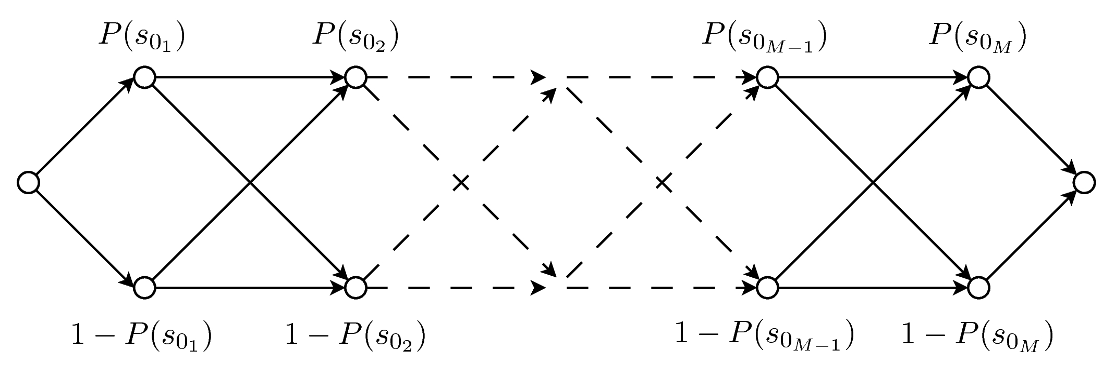
Figure 1: The problem of finding the K root selection sets with the highest probability of feasibility is transformed into a binary graph.

Because single root selections are binary decisions (for the left or the right open half plane) and are considered independent of each other the graph has a simple structure with interchangeable segments. The K shortest paths can be found with a simplified version of Yen's algorithm. Yen's algorithm finds the K shortest loopless paths between two nodes in a graph. As a result we get the K decision sets and further the related characteristic functions with the highest probability of feasibility. Now we can derive a thin film layer stack from every equivalent solution found. Since the method presented here only gives a probability of feasibility we have to check every solution if it complies with the given boundary conditions.

V Example and results

As stated in section I the results presented here concern only the problem of finding feasible solutions according to (1). To ensure that there exists at least one feasible solution in the solution set at first a thin film stack with N=30 layers was generated. The optical admittances of all layers were randomly chosen from the interval [1.4;2.6]. The admittances of the ambient and substrate media were selected to air with η₀=1.00 and glass with η_{N+1}=1.52. Now the associated response function K₀(s) for this filter stack was calculated and used as starting point like in section IV. To generate sufficient data in the Monte Carlo Simulation S≈10⁴ experiments were created from i.i.d. random variables which were uniformly distributed in the interval [1.7;2.3]. Again η₀ and η_{N+1} were selected as above. Now the search method presented in section IV was used to find feasible solutions. A solution was considered feasible if equation (1) with η_{L}=1.4 and η_{H}=2.6 was met for all layers. To compare the results also a standard linear search was conducted. The linear search runs through all possible root selections without using the information provided by the histograms.
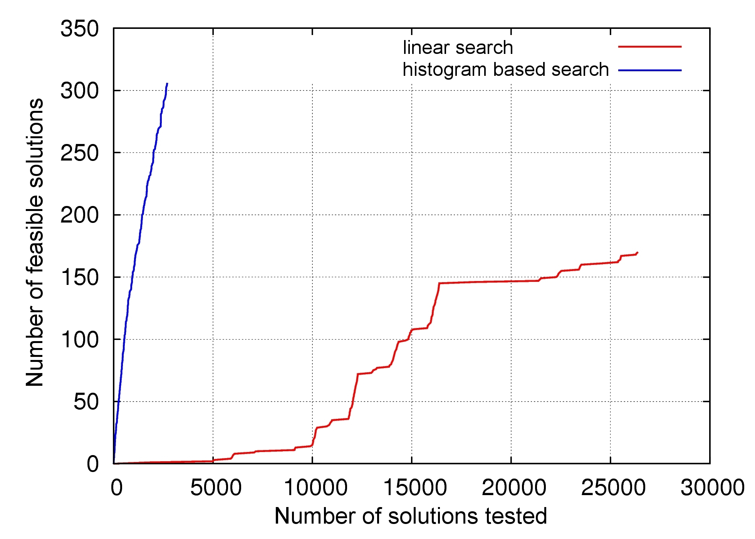
Figure 2: Comparison between the histogram based search method and a standard linear search.

The results are presented in figure 2. The number of examined solutions is plotted against the number of feasible solutions found. Both search methods were stopped after ten minutes runtime. As depicted in figure 2 the histogram based search finds about twice as much feasible solutions in the same time. In fact to retrieve the next solution the histogram based search needs more time than the linear search but this is outweighted by the higher probability of feasibility. All the simulations were implemented in Octave. By using dynamic binning, more sophisticated generation of the histograms, search algorithms and C++ language the performance can be farther improved. Since the boundary conditions only change if the technological setup has to be changed the time consuming Monte Carlo simulation has to be conducted only in this case.

References
- A. Rowinska-Schwarzweller, Exact synthesis of dielectric thin film filters, in: Proceedings of SPIE, 12-23 (2004).
- J. Y. Yen, Finding the k shortest loopless paths in a network, in: Mangement Science 17, 712-716 (1971).
- P. I. Richards, Resistor-Transmission-Line Circuits, in: Proceedings of the IRE 36, No. 2, 217-220 (1948).
- W. Bader, Polynomvierpole vorgeschriebener Frequenzabhängigkeit, in: Archiv für Elektrotechnik 34, No. 4, 181-209 (1940).
- V. Yadava, S. Sharma and K. Chopra, Variable refractive index optical coatings, in: Thin Solid Films 17, 243-252 (1973).
- S. Lange, H. Bartzsch, P. Frach and K. Goedicke, in: Pulse magnetron sputtering in a reactive gas mixture of variable composition to manufacture multilayer and gradient optical coeatings, in: Thin Solid Films 502, 29-33 (2006).
- H. Terui and M. Kobayashi, Refractive-index-adjustable SiO₂-Ta₂O₅ films for integrated optical circuits, in: Applied Physics Letters 32, 666 (1978).
- A. Herpin, Calcul du pouvoir reflecteur d'un systeme stratifie quelconque, in: Comptes Rendus 225, 182-183 (1947).
- J. A. Dobrowolski and S. H. C. Piotrowski, Refractive index as a variable in the numerical design of optical thin film systems, in: Applied Optics 21, 1502-1511 (1982).
- L. I. Epstein, The design of optical filters, in: Journal of the Optical Society of America 42, 806-808 (1952).
- M. C. Ohmer, Design of three-layer equivalent films, in: Journal of the Optical Society of America 68, 137-139 (1978).
- H. A. Macleod, Thin Film Optical Filters, Institute of Physics Publishing, third Edition, (2001).
- R. Unbehauen, Netzwerk und Filtersynthese, Oldenburg Verlag, vierte überarbeitete Auflage, (1993).

