Answers to reviewer A

- The Doppler angle of 69.5 degrees in letter is the angle of the probing beam and the surface of the glass capillary. The formula shown in the letter is the common formula where the Doppler angle is the angle that the flowing particle makes with the probing beam inside the medium. Because the flow velocity vector is parallel to the surface of the capillary the formula can be simplified by using Snell’s law:
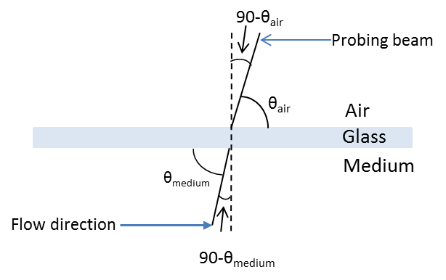
$$n_{air}\sin{{(90-θ}_{air})}=n_{medium}\sin{{(90-θ}_{medium})}$$
$$1*\cos{θ_{air}=n_{medium}\cos{θ_{medium}}}$$
$$\cos{θ_{air}=n_{medium}\cos{θ_{medium}}}$$
The formula in the letter was (θ was changed to θ_{m} at revised version)
$$v=\frac{f_{D}λ_{0}}{2n_{m}\cos{θ_{m}}}$$
and after using snell’s law formula simplifies to
$$v=\frac{f_{D}λ_{0}}{2\cos{θ_{air}}}$$
which was used on the velocity calculation and takes into account the refraction at the glass wall.

- Expression “shear tress” was corrected to “shear stress”.

