Properties of nematicons in low-birefringent nematic liquid crystals
Michał Kwaśny,¹ Urszula A. Laudyn¹, Filip A. Sala¹, Mirosław A. Karpierz¹ and Gaetano Assanto²
¹Faculty of Physics, Warsaw University of Technology, Koszykowa 75, 00-662 Warszawa,
²Nonlinear Optics and Opto-Electronics Laboratory, Department of Electronic Engineering,
University “Roma Tre", Rome, Italy
Received November; revised accepted; published
Abstract— In this work we investigate a nonlinear self-focusing effect and nematicons generation in low birefringent nematic liquid crystals (NLCs), where $n0.04$. Nematicons are obtained for larger optical powers but they are more stable in comparison to NLCs with typical birefringence, of the order of $n0.2$. In a nonlinear regime both polarization components exchange energy. Such behaviour is not observed in typical NLCs, where ordinary and extraordinary waves always propagate independently due to large walk off. The results were also compared with the numerical simulations, using a fully vectorial BPM code. Both, calculations and experimental results are in a good agreement.

Optical spatial solitons in nematic liquid crystals (NLCs), commonly referred to nematicons, result from balancing between diffraction and self-focusing effect due to reorientational nonlinearity [1]-[2]. This type of nonlinearity is derived from changes in refractive index in liquid crystalline medium caused by the intensity of light dependent. With the increasing of light intensity a birefringence axis of NLCs molecules change its direction and a gradient profile of refraction index is formed. Therefore an optically induced nonlinear waveguide is formed and it supports guiding light as a mode. Such trapped beam propagates without spreading at distances up to several millimeters. Nematicons have been demonstrated and investigated in several NLCs geometries, including planar [3], homeotropic [4], twisted and chiral [5-6]. A large electro-optic properties of liquid crystals combined with highly nonlocal response allowed for precisely control of trajectory of nematicons by using an external electric field as well as in completely optical methods, through interaction with optical field of additional beam(s).
The excitation of nematicons in planarly oriented NLCs sample is associated with the Freedericksz threshold effect [7] which can be avoided by pre-tilting molecules by external electric field or by rubbing the inner side of the cell to provide proper molecules alignment. When the director n is not perpendicular to the direction of electric field, reorientation occurs continuously [8]. Because the mutual orientation of molecular director and electric field vectors affects the NLCs nonlinearity, consequently the polarization and optical intensities required for nematicons generations vary together with launching conditions.
This work contains detailed study of nematicons propagation in a low-birefringent planarly oriented sample of NLCs. By launching a light beam in a $yz$ plane (Fig. 1), at arbitrary angles $α$ relative to the director, the optimal conditions for a self-trapping were defined. Furthermore, a high correlation between experimental results and fully vectorial simulations of beam propagation has been achieved [9]. Propagational properties of nematicons were compared between two NLCs mixtures, which possess low- and a typical birefringence value.

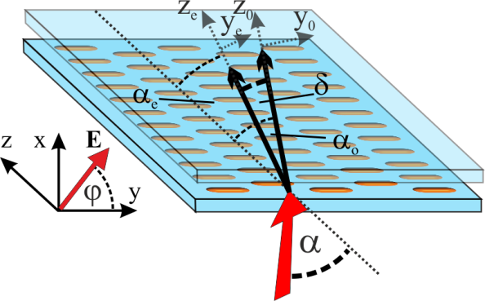
Fig. 1. Configuration of NLCs sample.

The planar liquid crystals sample, with a gap equal $d=50μm$, is presented in Fig. 1. A cell was filled with a low birefingent NLCs (1110 NLCs mixture synthesized at the Military University of Technology), with an ordinary and extraordinary refractive indices equal $n_{o}=1.45$ and $n_{e}=1.49$, respectively. As a light source is used a linearly polarized Nd:YAG laser operated at
$λ=1064nm$, with a combination of a polarizer and a half wave plate, to control input power and polarization. Beam is focused at the edge of a cell by a $20×$ microscope objective, which results in a beam waist equal $w_{0}=3.8μm$. For a fixed orientation of LC sample (described by $α$ angle in the range $0°÷45°$) a self-focusing conditions were analysed for different light polarization, including cases $E||x$ ($φ=90°$), $E||y$ $φ=0°$, as well as intermediate states. For the reasons of clarity, imaged by high resolution a CCD camera propagation of light is presented in a $y_{o}z_{o}$ reference frame, where $z_{o}$ is related to a wave vector of ordinary wave.
In low birefringent liquid crystals mixtures the minimal optical power required for self-trapping is higher (about 2-3 times) than in NLCs with typical value of $∆n$, both, nematics [10] and cholesterics [5]. Low birefringence value implies also smaller walk-off, the angular separation between ordinary and extraordinary waves. Maximum value is calculated to $δ=1.6°$, as against $δ=7°$ in 6CHBT (4-trans-4’-n-hexyl-cyclohexyl-isothiocyanatobenzene) [11], where refractive indices are $n_{o}=1.51$ and $n_{e}=1.67$ in the near infrared range.
Figure 2. presents detailed numerical propagation of light polarized at $φ=45°$ with respect to the propagation plane in two NLCs mixtures. All simulations were performed in a geometry, where wave vector is parallel to while director at rest is oriented at angle $-α_{e}$ with respect to $z_{o}$. This assumption significantly simplifies the calculations, however is consistent with the experimental conditions.

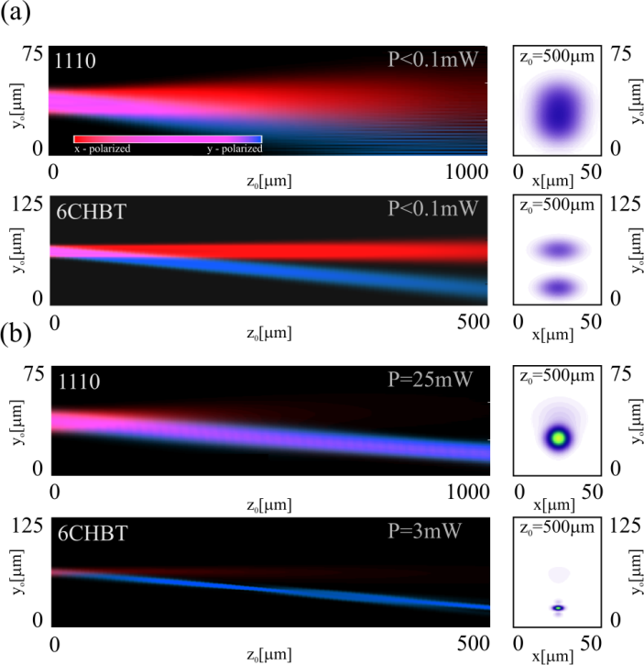
Fig. 2. Numerical simulations of a beam evolution in the $y_{o}z_{o}$for $α=45°$ and $φ=45°$. Propagation results are presented in linear (a) and nonlinear case (b) for two NLCs mixtures characterized by different $∆n$.

In a liner case (Fig. 2a) both waves (ordinary and extraordinary) undergo a diffractive extension and propagate independently in their own paths. At the end of a cell, in a $xy$ plane view, both waves are clearly separated. When optical power is high enough to induce a nonlinear changes in refractive index distribution an extraordinary beam starts to self-collimate and for a $P=25m$ (1110) or $P=3m$ (6CHBT) a nematicon is formed (Fig. 2b). Self-trapped beam induced by two polarization components leads to a diffractive background, caused by exchange energy between ordinary and extraordinary components. Such results are confirmed experimentally.
Figure 3. shows the evolution of a beam for three input polarizations, while a launching direction and optical power are remain constant. Firstly, ordinarily polarized light ($φ=90°$) diffracts for optical power up to about $100mW$. Temporally unstable nematicon can be formed when thermo-optic instabilities entail convective molecular motion and overcoming the threshold effect. For an extraordinarily polarized light ($φ=0°$) molecules collocation with respect to the wave vector is the most optimal in terms of energy needed for their spatial redistribution in a $y_{o}z_{o}$ plane. In this case the optical power needed for a nematicon generation is the smallest, equal $P=15mW$. A mixed polarized light with the same optical power also is capable of inducing a nematicon but because of power coupling between both polarization components, the extraordinary part of beam is less confined and a blurred diffractive background is observed. However increasing input power of more than $20mW$ apparent increasing of self-focusing is observed. As the optical power is rising, more and more part of $x-$polarized beam is trapped within, which results in reducing of a background in a proximity of a nematicon.
On the other hand, keeping polarization of a beam fixed and changing input angle $α$, starting from the optimized value equal $45°$ to $0°$, the self-confinement takes place for higher and higher powers. In a case of a normal incidence ($α=0°$) the $x$-polarized light is connected with a threshold effect and unstable propagation in nonlinear case. Inversely, the $y$-polarized light no reorientation takes place and beam is diffracted independently from the excitation power.

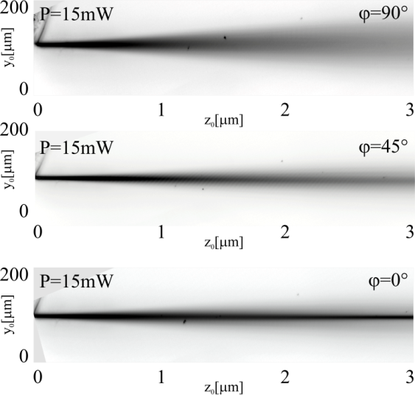
Fig. 3. Experimental results of beam evolution launched for $α=45°$, $P=15mW$ and for three different polarizations: $φ=(0°, 45°, 90°)$, in the $y_{o}z_{o}$ reference system.

In addition to long propagation distance of nematicons, the second very important factor is their stability. Considering the best optimized case, when reorientation of molecules occurs only in a $yz$ plane and when the minimal optical power resulting in formation of nematicon, the stability of a self-guided wave can be presented as the time dependent location of a nematicon at the end of an optical system. Such analysis is presented in a Fig. 4 and it concerns output positions of two beams after propagation distance $z_{o}=4mm$. Both waves are launched at $α=45°$ and polarized at $φ=(0°, 45°)$. In both cases the maximum deviation of trajectories from the mean values is less than five microns. Separation between nematicons obtained from different polarized beams measured in observation plane ($xy$) is about $23μm$. Noticeably lower fluctuations in the position of beam polarized at $φ=0°$ arise due to absence of the ordinarily polarized component.

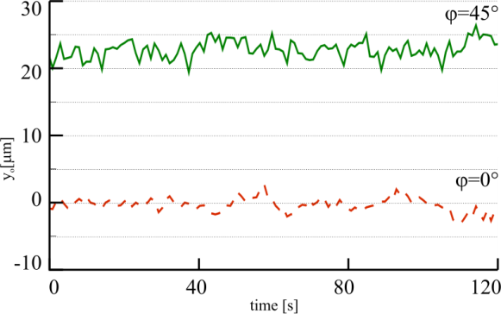
Fig. 4. Output position of nematicons in $z=4mm$, in case of extraordinary wave excitation ($φ=0°$, $P=15mW$, dashed line) and a mixed-polarized beam ($φ=45°$, $P=20mW$, solid line).

Concluding this paper, low birefringent nematic liquid crystals support stable nematicons propagation over a distance of 4 mm but compared with the NLCs with typical value of birefringence, they request larger optical powers. The optimal self-focusing conditions are satisfied when the wave vector k and director n form an angle $α=45°$ and when propagation concerns an extraordinarily polarized beam ($φ=0°$). In a contrary to evolution of light in high birefringent NLCs, in the present case a nonlinear propagation leads to a coupling between ordinary and extraordinary components of the wave
This work was partially supported by the National Science Centre.

References
- G. Assanto, M. A. Karpierz, Liq. Cryst. 36, 1161 (2009).
- G. Assanto, Nematicons, (John Willey& Sons 2012).
- M. Peccianti, G. Assanto, A. De Luca, C. Umeton, I. C. Khoo, Appl. Phys. Lett. 77, 7 (2000).
- M. A. Karpierz, M. Sierakowski, M. Swillo, and T. Wolinski, Mol. Cryst. Liq. Cryst. 320, 157 (1998).
- U. A. Laudyn, M. Kwasny, M. A. Karpierz, Appl. Phys. Lett. 94, 091110 (2009).
- U. A. Laudyn, M. Kwasny, K. Jaworowicz, K. A. Rutkowska, M. A. Karpierz, G. Assantyo, Phot. Lett. Poland 1, 7 (2009)
- I. C. Khoo, Liquid Crystals, 2nd edition, (Wiley & Sons, New Jersey 2007).
- A. Piccardi, A. Alberucci, G. Assanto, Appl. Phys. Lett. 96, 061105 (2010).
- F. A. Sala, M. A. Karpierz, Opt. Express 20 (13) 13923 (2012).
- A. Piccardi, M. Trotta, M. Kwasny, A. Alberucci, R. Asquini, M. Karpierz, A. D’Alessandro, G. Assanto, Appl. Phys. B 104, 805 (2011).
- R. Dąbrowski, J. Dziaduszek and T. Szczuciński, Mol. Cyst. Liq. Cyst. 124, 241 (1985).

E-mail: mkwasny@if.pw.edu.pl

