The influence of pitch and birefringence on nematicon propagation at the disclination lines in chiral nematic liquid crystals
Michał Kwaśny, Bartłomiej W. Klus and Urszula A. Laudyn
¹Faculty of Physics, Warsaw University of Technology, Koszykowa 75, 00-662 Warszawa,
Received December; revised accepted; published
Abstract — In this work we study the influence of pitch and birefringence on nematicon propagation at the disclination lines in a wedge shaped planarly oriented sample. We demonstrate that changing the structure parameters can be employed for efficient bending of the soliton trajectory, as a result of reflection.

The concept of optical solitons is inherently associated with many nonlinearity driven propagational effects. Spatial optical solitons, i.e. nondispersive and nondiffractive beams propagating in nonlinear media, are formed thanks to an interplay between diffraction, which tends to spread the beam and the self-induced nonlinear refractive index change of the medium, which focuses the beam [1]. Among others, spatial optical solitons in nematic liquid crystals (NLCs), commonly referred to nematicons, plays a crucial role [2]–[3]. The main source of interest includes the high nonlinearity stemming from molecular reorientation. This type of nonlinearity is derived from changes in refractive index in liquid crystalline medium caused by the intensity of light dependent. With the increasing of light intensity a birefringence axis of NLCs molecules change its direction and a gradient profile of refraction index is formed. Nematicons have been demonstrated and investigated in several NLCs geometries, including planar [4], homeotropic [5], twisted and chiral [6-10]. They can be used to create reconfigurable optical circuits created by light alone where all-optical switching or processing is achieved through the evolution and interaction of the many soliton beams. Light guiding, coupling, routing and combining are essential to optical signal processing, and these crucial light manipulation lead to an important development in optical communication systems. By increasing the complexity of crystalline geometry, more advanced light controls could be achieved for wide applications. Among them, there is a growing interest of research on the use of chiral nematic liquid crystals (chiral nematics, cholesterics, ChNLCs) with a helical arrangement of molecules [8-10]. The very promising configuration is obtained using the wedge-shaped slit and a chiral substance. The latter leads to the formation of the Grandjean steps, parallel bands separated by disclination lines [11-12]. It has been already demonstrated [9-10] that non-uniform distribution of refractive index along the thickness of the liquid crystal in wedge cell enables easily control of the direction of signal propagation. In such prepared cell a disclination lines are formed, i.e. the lines where distribution of the refractive index is discontinuous
This work contains insight in the nematicon propagation in the highly disturbed area around disclination line in mixtures with different pitch and birefringence value respectively. The main idea of the presented experimental results is related to reflection, refraction and change in the direction of nematicon’s propagation in ChNLCs in a wedge cell. In this work we investigated low-birefringent NLC 1110 [13] with no = 1.452 and ne = 1.498 at room temperature and at λ=1.064 μm with chiral dopant at a weight concentration of about 5% and 2%, which gives the pitch about 8μm and 20μm respectively and a typical birefringent NLC E7 (Merck) with no = 1.504 and ne = 1.695 at room temperature and λ=1.064 μm with chiral dopant with pitch about 20 μm.

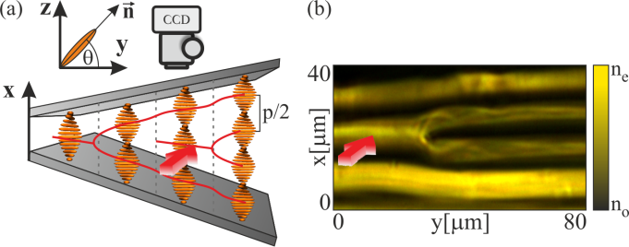

Fig. 1. (a) Sketch of experimental setup and chiral structure confined in a wedge shaped cell with refractive index profile for the incident light beam polarized along y-axis propagating in z-direction; (b) photo taken in yx plane by illuminating with white light of a refractive index distribution close to disclination line.

The experimental setup and cell geometry are sketched in Fig. 1a. The chiral structure is sandwiched between two glass plates making a small angle and treated for planar anchoring in the same direction. As a consequence, a thickness of a sample is gradually changed along the sample length. Nematicons were generated by a monochromatic beam from a Nd:YAG laser operating with the wavelength λ=1.064μm focused on the NLC layer by the 20x micro-objective into a laser spot of several micrometers in the sample (w₀~3.8μm). The input linear polarization of the beam was controlled by a half-wavelength plate. The light intensity distribution of the propagating beam inside the cell was acquired by collecting the scattered light out of the top slide by CCD camera. In the investigated configuration a light beam propagates in the z-direction, parallel to the glass plates. A nematicon is generated by injecting a polarized beam with polarization parallel to y axis with the wave vector parallel to z axis.
According to Fig. 1a, when a y-polarized light beam is launched perpendicular to the helical axis it experiences a refractive index continuously varying across x-direction taking the values from ordinary to the extraordinary one. As a consequence, in considered geometry one can distinguish high index regions throughout the cell thickness, where the light beam (of the proper polarization) tends to propagate [8]. The number of such regions is determined by the pitch value and is equal to 2d/p (where d is the cell thickness), what means that the true periodicity is the half-pitch. The resultant texture depends on a helix pitch p and the NLC birefringence. The pitch p determines the thickness and number of layers and the birefringence determines the contrast between the layers. It means that the medium is stratified along x direction, and if the ChNLCs is confined in a wedge cell the refractive index distribution is affected by a disclination line along x. Disorder along x-axis is the difference in refractive index for the same value of x which results in an index change for y-polarized beam propagating across the disclination line. The refractive index perceived by the impinging beam from the right side of disclination is different than sensed by the beam from the left side of disclination line (for the same x value). As a consequence, nematicon created at the right side of disclination after passing the disclination collapses [9].
In an ideal situation, namely ideal refractive index distribution (Fig. 1b), the beam propagating on the right side of disclination line sees extraordinary refractive index, while on the left side, for the same x-value the beam sees ordinary refractive index. It means that when beam strikes a disclination line from right to left it experiences a refractive index shift and the beam undergoes reflection and is repelled by the interface. In low birefringent chiral nematic liquid crystals mixtures the minimal optical power required for self-trapping is higher than in NLCs with typical value of $∆n$ [14-15] and also due to the Frank elastic constant K₂₂ which is higher in 1110 ChNLC than E7.
Figure 2 compares the influence of pitch and birefringence in case of nematicon striking the disclination line. Firstly, we compare low birefringent ChNLC (Δn=0.04) with two different pitch value (8 and 20μm respectively). Launching beam at the same angle to the disclination line we observe that in the case of smaller pitch the beam is splitted into two, one part is reflected from disclination line and the second one propagates through disclination without any changes in its direction. The low pitch means thinner optical layer in comparison to beam waist. Increasing the pitch value causes that the whole beam is reflected for the same angle of incidence.

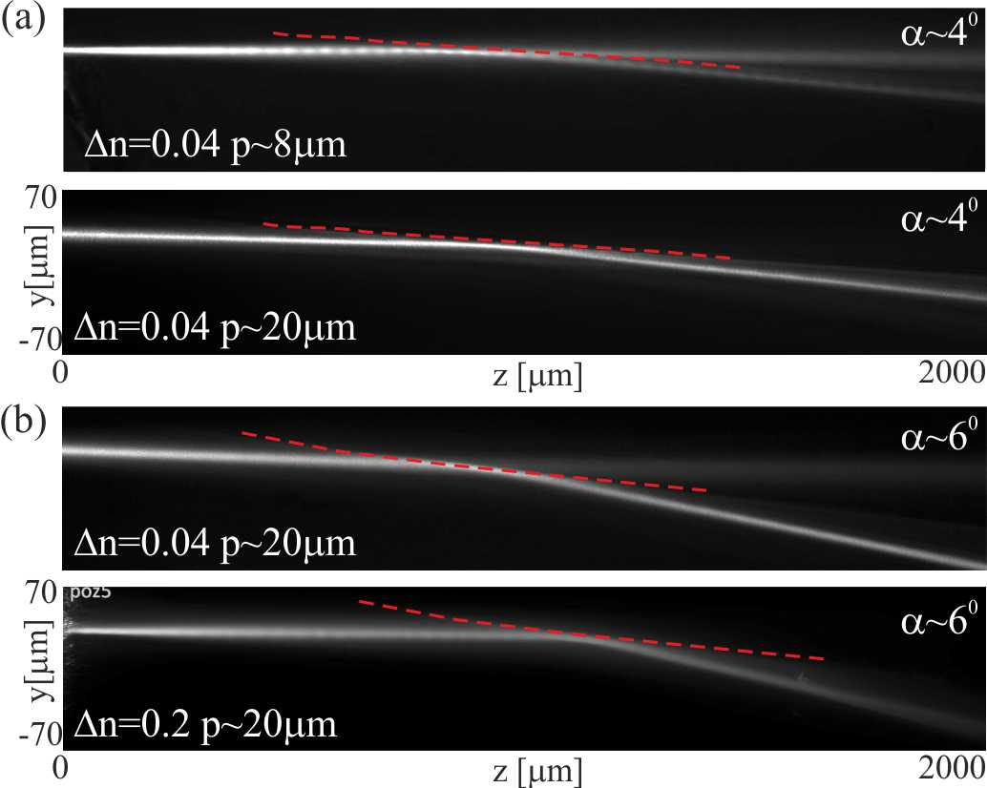

Fig. 2. Experimental results taken for mixtures with different pitch and birefringence value showing the beam reflectance at the disclination line (a) low-birefringent 1110 NLC with pitch 8 and 20 μm respectively; (b) comparison between low and typical birefringent NLC with equal pitch (~20μm)

Moreover, keeping the pitch value the same and increasing the birefringence we observe similar behaviour. In this case the pitch was 20μm, and the beam was injected at the angle of 6 degree to the disclination line. The angle was chosen so that in the case of a small birefringence the beam is divided into two: reflected and passing beam. Increasing the birefringence causes that entire beam is reflected due to the higher reflectance index. Results depicted in Fig. 2 can be summarized by the fact that thicker layer (higher pitch value) and higher effective refractive index inside the layer means stronger light beam guiding i.e. the mode is stronger guided in the layer.
In addition to above we also analyse the stability with increasing input beam power. In case of low birefringent and small pitch (1110 ChNLC with 8μm pitch) increasing the input beam power leads to energy coupling between the divided beams (Fig. 3a). Higher power means stronger reorientation of molecules in both sides of disclination line and consequently lower difference in refractive index distribution. As a consequence the reflected part of the beam is less confined and a blurred diffractive background is observed. Further increasing of beam power leads to self-focusing of a passing beam and a whole beam passes the disclination line without changes in its propagation direction.
In the case of 1110 ChNLC with higher pitch (wider layer) as well as E7 ChNLC increasing the beam power has little effect on the stability of the reflected beam or its direction of propagation. Increasing the input beam also leads to stronger reorientation however since the whole beam is reflected, it actually increase the difference in refractive index distribution on both sides of disclination line.

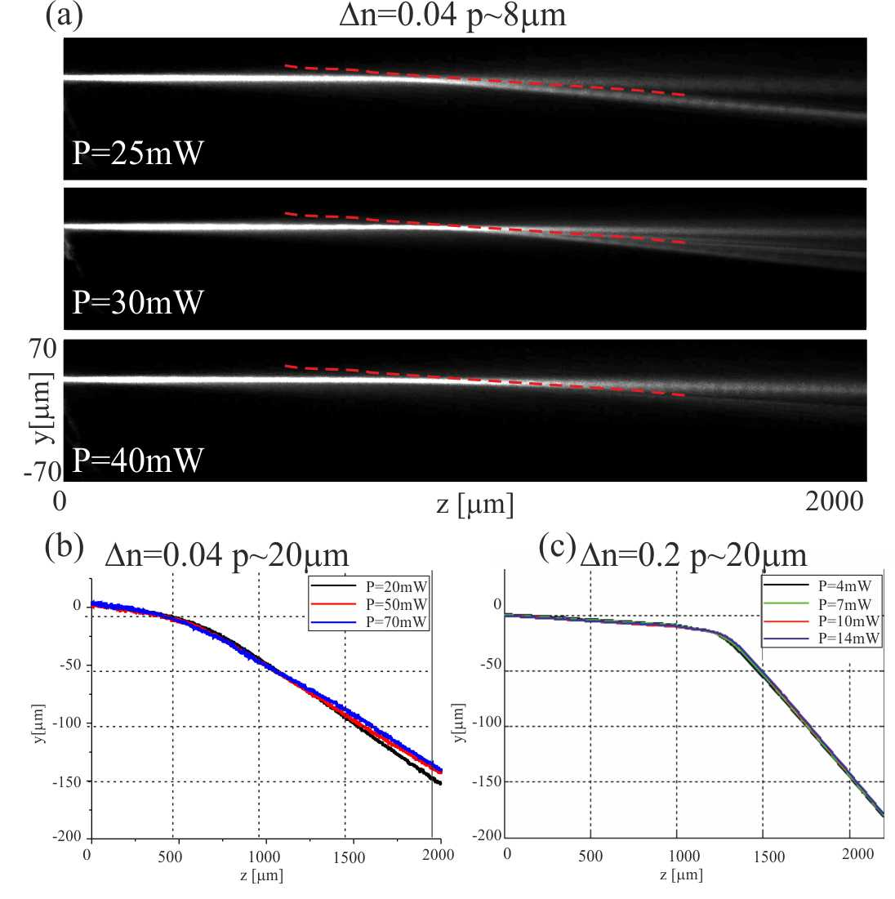
Fig. 3. The stability of obtained results from Fig. 2 with increasing incident beam power (a) photos of light beam propagation and nematicon trajectory in mixture 1110 with pitch 8μm; (b)-(c) stability of mixtures with equal pitch 20μm but different birefringence: low birefringent 1110 mixture (b) and typical birefringent E7 (c)

Furthermore, depending on the beam launching angle with respect to the disclination lines it is possible to control the direction of nematicon’s propagation. Figure 4 presents the changes in nematicon trajectory as a function of angle of beam incidence. The maximal angle of incidence depends on the refractive index shift on both sides of disclination, thus straightly depends on birefringence of used NLC mixtures. Using the principal of refraction and reflection, the maximum angle in respect to disclination line for which the beam undergoes reflection was estimated to be about 10⁰ in low-birefringent 1110 ChNLCs and about 20⁰ in E7. This assumption however does not include absorption, scattering loses as well as walk-off of a beam which highly affects the maximal angle. Indeed, in experiment the reflection of a beam from disclination line was observed for angles up to 8⁰ in 1110 and up to 12⁰ in E7 ChNLC.

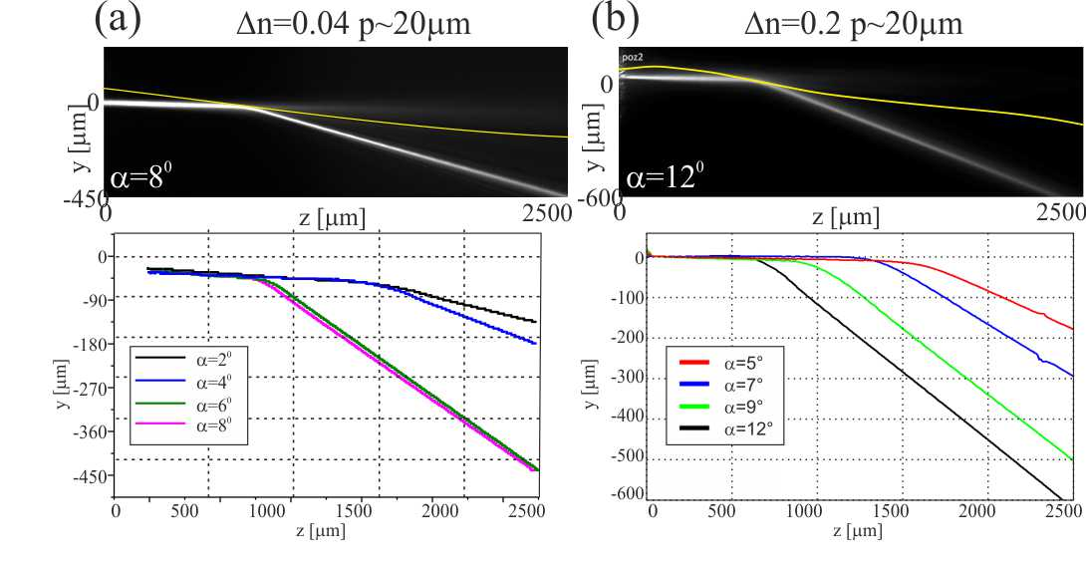
Fig. 4. Comparison between low (a) and typical birefringent (b) NLC with equal pitch and different angle of incident beam in respect to disclination line

Concluding this paper, we study the influence of pitch and birefringence on nematicon propagation at the disclination lines in a wedge shaped planarly oriented sample. We demonstrate that changing the structure parameters can be employed for efficient bending of the soliton trajectory, as a result of reflection.

This work was supported by the National Science Centre under the decision number DEC-2012/05/D/ST7/00147.

References
- Spatial Solitons, ed. S. Trillo, W. Torruellas (Berlin, Spriger Verlang, 2001)
- G. Assanto, M. A. Karpierz, Liq. Cryst. 36, 1161 (2009).
- G. Assanto, Nematicons, (John Willey& Sons 2012).
- M. Peccianti, G. Assanto, A. De Luca, C. Umeton, I. C. Khoo, Appl. Phys. Lett. 77, 7 (2000).
- M. A. Karpierz, M. Sierakowski, M. Swillo, and T. Wolinski, Mol. Cryst. Liq. Cryst. 320, 157 (1998).
- U. A. Laudyn, M. Kwasny, M. A. Karpierz, Appl. Phys. Lett. 94, 091110 (2009).
- U A. Laudyn, K. Jaworowicz, M. A. Karpierz, Mol. Cryst. Liq. Cryst. 489, 214 (2008)
- U. A. Laudyn, P. S. Jung, K. B. Zegadło, M. A. Karpierz and G. Assanto, Opt. Letters 39, 6399 (2014)
- U. A. Laudyn, M. A. Karpierz Appl. Phys. Lett.103 221104 (2013)
- M. Kwaśny, U. Laudyn, K. Rutkowska, M. Karpierz J. of Nonl. Opt. Phys.&Mat. 23, 1450042 (2014)
- H. S. Kitzerrow, Ch. Bar, Chirality in Liquid Crystals, Springer 2001, New York
- P. Oswald, P. Pieranski, Nematic and Cholesteric Liquid Crystals: Concepts and Physical Properties Illustrated by Experiments, Taylor & Francis 2005
- 1110 nematic mixture was synthesized by Prof. R. Dabrowski at Military University of Technology in Warsaw
- M. Kwasny, U. A. Laudyn, F. A. Sala, A. Alberucci, M. A. Karpierz and G. Assanto, Phys. Rev. A 86, 013824 (2012)
- B. Klus, U. A. Laudyn, M. A. Karpierz, B. Sahraoui, Opt. Express 22, 30257 (2014)

